

# Oricom Care95 Big Button Amplified Speakerphone

## Type of device: Landline - Standard

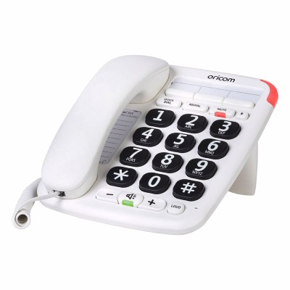

Button Type : Physical Keypad

Average Price : $65 as of 29 06 2022

## Accessibility Features:

### Hearing Impairment and Deaf

* Hearing Aid Microphone Coupling
* Hearing Aid Telecoil Coupling

Visual Alerts - Incoming Calls

### Vision

* Key Marker – Raised '5'
* Key Numbers - Standard Layout

Key Press - Vibration or Click

### Physical

* Flat Back for Table Top Operation
* Physical Dialling Keys

Speaker-phone option

## How and where to get it from?

You can buy this phone from [Oricom Care95 Big Button Amplified Speakerphone Website](https://oricom.com.au/product/care95-amplified-big-button-phone/), [Bunnings](https://www.bunnings.com.au/search/products?q=big%20button%20phone&sort=BoostOrder&page=1), and other retailers.

## More information is available on:

[Oricom Care95 Big Button Amplified Speakerphone User Guide PDF Download Website](https://oricom.com.au/wp-content/uploads/2020/09/OR019151-CARE95-User-Guide_07-10-20.pdf)